**Day 44**

**Thread Scheduler in Java**

A component of Java that decides which thread to run or execute and which thread to wait is called a **thread scheduler in Java**. In Java, a thread is only chosen by a thread scheduler if it is in the runnable state. However, if there is more than one thread in the runnable state, it is up to the thread scheduler to pick one of the threads and ignore the other ones. There are some criteria that decide which thread will execute first. There are two factors for scheduling a thread i.e. **Priority** and **Time of arrival**.

**Priority:** Priority of each thread lies between 1 to 10. If a thread has a higher priority, it means that thread has got a better chance of getting picked up by the thread scheduler.

**Time of Arrival:** Suppose two threads of the same priority enter the runnable state, then priority cannot be the factor to pick a thread from these two threads. In such a case, **arrival time** of thread is considered by the thread scheduler. A thread that arrived first gets the preference over the other threads.

Thread Scheduler Algorithms

On the basis of the above-mentioned factors, the scheduling algorithm is followed by a Java thread scheduler.

First Come First Serve Scheduling:

In this scheduling algorithm, the scheduler picks the threads thar arrive first in the runnable queue. Observe the following table:

|  |  |
| --- | --- |
| **Threads** | **Time of Arrival** |
| t1 | 0 |
| t2 | 1 |
| t3 | 2 |
| t4 | 3 |

In the above table, we can see that Thread t1 has arrived first, then Thread t2, then t3, and at last t4, and the order in which the threads will be processed is according to the time of arrival of threads.

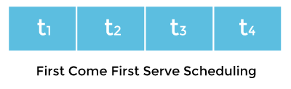

Hence, Thread t1 will be processed first, and Thread t4 will be processed last.

Time-slicing scheduling:

Usually, the First Come First Serve algorithm is non-preemptive, which is bad as it may lead to infinite blocking (also known as starvation). To avoid that, some time-slices are provided to the threads so that after some time, the running thread has to give up the CPU. Thus, the other waiting threads also get time to run their job.

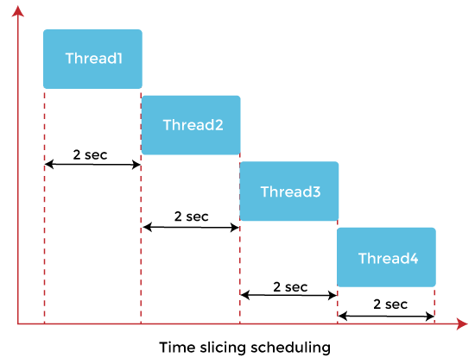

In the above diagram, each thread is given a time slice of 2 seconds. Thus, after 2 seconds, the first thread leaves the CPU, and the CPU is then captured by Thread2. The same process repeats for the other threads too.

Preemptive-Priority Scheduling:

The name of the scheduling algorithm denotes that the algorithm is related to the priority of the threads.

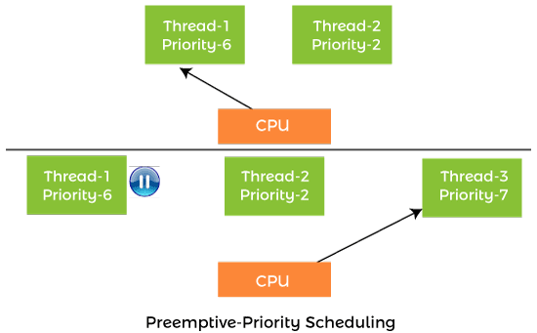

Suppose there are multiple threads available in the runnable state. The thread scheduler picks that thread that has the highest priority. Since the algorithm is also preemptive, therefore, time slices are also provided to the threads to avoid starvation. Thus, after some time, even if the highest priority thread has not completed its job, it has to release the CPU because of preemption.

Working of the Java Thread Scheduler

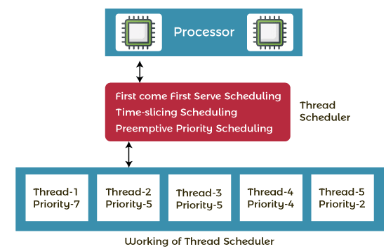

Let's understand the working of the Java thread scheduler. Suppose, there are five threads that have different arrival times and different priorities. Now, it is the responsibility of the thread scheduler to decide which thread will get the CPU first.

The thread scheduler selects the thread that has the highest priority, and the thread begins the execution of the job. If a thread is already in runnable state and another thread (that has higher priority) reaches in the runnable state, then the current thread is pre-empted from the processor, and the arrived thread with higher priority gets the CPU time.

When two threads (Thread 2 and Thread 3) having the same priorities and arrival time, the scheduling will be decided on the basis of FCFS algorithm. Thus, the thread that arrives first gets the opportunity to execute first.

# Thread.sleep() in Java

The Java Thread class provides the two variant of the sleep() method. First one accepts only an arguments, whereas the other variant accepts two arguments. The method sleep() is being used to halt the working of a thread for a given amount of time. The time up to which the thread remains in the sleeping state is known as the sleeping time of the thread. After the sleeping time is over, the thread starts its execution from where it has left.

### The sleep() Method Syntax:

Following are the syntax of the sleep() method.

1. **public** **static** **void** sleep(**long** mls) **throws** InterruptedException
2. **public** **static** **void** sleep(**long** mls, **int** n) **throws** InterruptedException

The method sleep() with the one parameter is the native method, and the implementation of the native method is accomplished in another programming language. The other methods having the two parameters are not the native method. That is, its implementation is accomplished in Java. We can access the sleep() methods with the help of the Thread class, as the signature of the sleep() methods contain the static keyword. The native, as well as the non-native method, throw a checked Exception. Therefore, either try-catch block or the throws keyword can work here.

The Thread.sleep() method can be used with any thread. It means any other thread or the main thread can invoke the sleep() method.

### Parameters:

The following are the parameters used in the sleep() method.

**mls:** The time in milliseconds is represented by the parameter mls. The duration for which the thread will sleep is given by the method sleep().

**n:** It shows the additional time up to which the programmer or developer wants the thread to be in the sleeping state. The range of n is from 0 to 999999.

The method does not return anything.

### Important Points to Remember About the Sleep() Method

Whenever the Thread.sleep() methods execute, it always halts the execution of the current thread.

Whenever another thread does interruption while the current thread is already in the sleep mode, then the InterruptedException is thrown.

If the system that is executing the threads is busy, then the actual sleeping time of the thread is generally more as compared to the time passed in arguments. However, if the system executing the sleep() method has less load, then the actual sleeping time of the thread is almost equal to the time passed in the argument.